**BAHRIA UNIVERSITY (KARACHI CAMPUS**)

**Department of Software Engineering.**

**Assignment 03 (Fall 2022)**

**Course Title: Applied Physics Course Code: GSC-114**

**Class: BSE 1B Shift: Morning**

**Course Instructor: Engr. Rizwan Fazal Date: 04 Jan 2023**

**Submission: 15 Jan 2023 Max Marks: 10 Points**

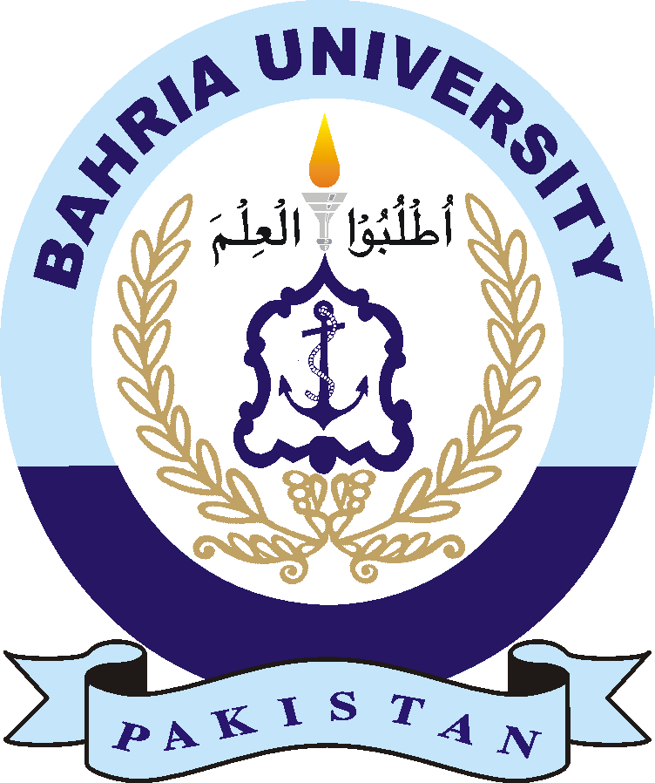

Abdullah

02-131222-099

1 B

**Submitted By:**

Name: _________________________________

Registration Number: _____________________

Section: ________________________________

Assignment No 03